Salary Analysis Rmarkdown Conversion

Dylan Projansky

9/13/2017

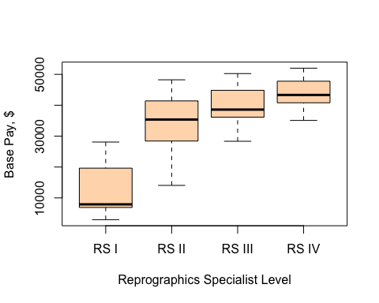

Boxplot of Salary Distribution

|  |  |
| --- | --- |
| Job.Title | Base.Pay |
| REPROGRAPHICS SPECIALIST I | 12969.96 |
| REPROGRAPHICS SPECIALIST II | 34171.12 |
| REPROGRAPHICS SPECIALIST III | 40001.32 |
| REPROGRAPHICS SPECIALIST IV | 43859.16 |

The Base Pay of Reprographic Specialists was taken from the California State University system. The salaries were taken of the specialists at four levels (I, II, III, IV).